

Kids area Application

**Project Manger**

Mohamed Agami Fikry Qub

**The Supervision of**

Innova Egypt

Contents

1. Project overview 4

1.1. Project Description 4

1.2. Project Scope 5

1.3. Assumptions 6

1.4. Constraints 6

2. Project Start-Up 7

2.1. Project Life Cycle 7

2.2. Methods, Tools, and Techniques 8

2.3. Estimation Methods and Estimates 9

2.4. Schedule Allocation 9

2.5. Resource Allocation 10

2.6. Budget Allocation 10

3. Risk Management 11

4. Project time management 12

4.1. Name task. 12

4.2. PERT approach 13

4.3. Network diagram. 14

4.4. Calculator early start and early finish and late start and late finish and free float and total float. 15

4.5. Gantt chart 16

5. Economic Feasibility Study 18

6. Data flow diagram 20

6.1. Context diagram (Level 0) 20

6.2. data flow diagram (Level 1) 21

7. Use Case 24

8. Activity diagram 25

9. Design and implementation. 26

10. Testing 39

# Project overview

## Project Description

The Kids Area Software Application is a dedicated platform designed to provide children with a safe, engaging, and educational digital environment. The application aims to balance entertainment and learning by offering interactive games, educational content, and creative activities tailored to different age groups. Additionally, it will feature robust parental controls to ensure a secure experience for children while providing parents with the tools to monitor and manage their child’s digital interactions.

Objectives

1. **Engagement and Learning:** Develop an application that captivates children's interest while fostering their cognitive, social, and emotional development through educational content.
2. **Safety and Security:** Ensure a secure digital environment with advanced parental controls and data protection measures.
3. **User-Friendly Experience:** Create an intuitive and visually appealing interface that is easy for children to navigate and enjoyable to use.
4. **Performance and Reliability:** Deliver a responsive and reliable application that performs consistently across various devices and platforms.

Key Features

1. **Interactive Games:** A collection of fun and educational games that promote learning in areas such as math, language, science, and problem-solving.
2. **Educational Content:** Videos, stories, and quizzes designed to enhance knowledge and comprehension skills.
3. **Creative Activities:** Tools for drawing, storytelling, and music creation to stimulate creativity and self-expression.
4. **Parental Controls:** Features allowing parents to set usage limits, monitor activity, and control accessible content.
5. **User Profiles:** Customizable profiles for each child, enabling personalized experiences and tracking progress.

## Project Scope

The Kids Area Application is designed to provide a secure, engaging, and educational digital environment for children. The application will feature interactive games, educational content, creative activities, and robust parental controls. It will be developed to support multiple platforms including iOS, Android, and web browsers, desktop applications ensuring accessibility and convenience for users. This project aims to deliver a high-quality, reliable, and user-friendly application that meets the needs of children and their parents.

|  |
| --- |
| Project Includes |
| ****User Interface and Experience****: Development of an intuitive and visually appealing interface tailored for children. |
| ****Educational Content**: A library of videos, stories, quizzes, and other educational materials.** |
| ****Creative Activities**: Tools for drawing, storytelling, and music creation.** |
| ****User Profiles**: Customizable profiles for each child to provide personalized experiences.** |
| ****Interactive Games**: A variety of educational and entertaining games focusing on subjects like math, language, science, and problem-solving.** |
| ****Security**: Implementation of stringent security measures to protect user data**. |

|  |
| --- |
| Project Excludes |
| ****Custom Hardware**: No development or support for custom hardware devices or accessories.** |
| ****In-Person Support**: No provision for on-site customer support or physical training sessions.** |
| ****Advanced AI Features**: No implementation of advanced artificial intelligence or machine learning features beyond basic recommendations and progress tracking.** |

## Assumptions

|  |
| --- |
| Assumptions |
| ****Platform Compatibility**: The application will be compatible with major operating systems, including iOS, Android, and web browsers.** |
| ****Internet Connectivity**: Users will have a stable internet connection to access most features of the application.** |
| ****Device Specifications**: The target user devices (tablets, smartphones, and PCs) will meet the minimum hardware and software requirements to run the application efficiently.** |
| ****Security and Privacy**: Users will provide consent for data collection in compliance with relevant data protection regulations such as GDPR and COPPA.** |

## Constraints

|  |
| --- |
| Constraints |
| ****Project Deadlines**: The project has a fixed deadline for initial launch, which must be met to align with market opportunities and stakeholder expectations.** |
| ****Development Schedule**: Limited time for development sprints due to the fixed project timeline**. |
| ****Funding Limitations: The project has a defined budget that cannot be exceeded.**** |
| ****Resource Allocation**: Limited financial resources for hiring additional personnel or acquiring expensive tools and technologies.** |
| ****Human Resources**: Availability of skilled developers, designers, testers, and other essential team members may be limited.** |

# Project Start-Up

## Project Life Cycle

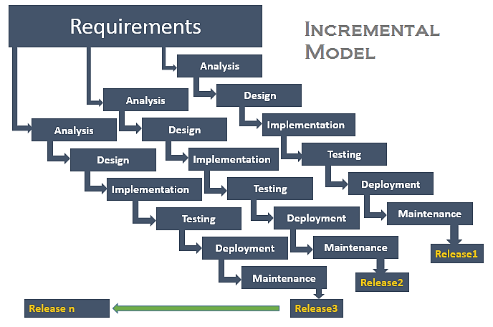

1. **Requirement analysis:**The product analysis expertise identifies the requirements in the first phase of the incremental model. The requirement analysis team also understands the system's functional needs. This phase is critical for developing software using the incremental methodology.
2. **Design & Development:** The design of the system functionality and the development technique is completed successfully in this phase of the Incremental model of SDLC. The incremental model employs the style and development phase when software creates new functionality.
3. **Implementation:**The coding phase of the development system is enabled by the implementation phase. It entails the final code created throughout the design, development, and testing process. Following the conclusion of this phase, the number of working products has increased and updated to the final system product.
4. **Testing:** The testing step of the incremental approach examines the performance of each current function and new capabilities. Various techniques are utilized to test the behavior of each task throughout the testing phase.

## Methods, Tools, and Techniques

* **Methods**

1. **Incremental development:** is an approach to software development where a project is broken down into smaller, manageable segments called increments. Each increment represents a portion of the overall project functionality, which is developed, tested, and delivered independently.
2. **User-Centered Design (UCD):** Design the application with a focus on the needs and preferences of the target users, namely children, parents, and educators. Conduct user research, usability testing, and persona development to ensure the application's usability and appeal.

* **Tools**

1. **NetBeans IDE** is a free and open-source integrated development environment for application development on Windows, Mac, Linux, and Solaris operating systems. The IDE simplifies the development of web, enterprise, desktop, and mobile applications that use the Java and HTML5 platforms.
2. **Microsoft Access is** a popular information management tool that helps you store all kinds of information for reporting, analysis, and reference. With Microsoft Access, you can manage data more efficiently and analyze large amounts of information. As a business, using Microsoft Excel can't prove to be sufficient.
3. **Microsoft Word** is a word processing program that allows for the creation of both simple and complex documents. With Office 365, you can download the application to your hard drive and will also have access to the online version.

* **Techniques**
  1. **Java** is a multi-platform, object-oriented, and network-centric language that can be used as a platform. It is a fast, secure, reliable programming language for coding everything from mobile apps and enterprise software to big data applications and server-side technologies.
  2. **SQL** is used to communicate with a database. According to ANSI (American National Standards Institute), it is the standard language for relational database management systems. SQL statements are used to perform tasks such as updating data on a database or retrieving data from a database.

## Estimation Methods and Estimates

|  |  |
| --- | --- |
| ****Description**** | ****[ Best / Most Likely / Worst]**** |
| ****Effort in person-months or person-hours**** | 280 / 310 / 330 person-months or person-hours |
| ****Schedule in calendar months**** | 5 / 6 / 7 calendar months |
| ****Budget in dollars**** | 100,000 LE / 150,000 LE / 200,000 LE |
| ****Level of Uncertainty**** | Moderate |

## Schedule Allocation

|  |  |
| --- | --- |
| ****Major Milestone/Deliverable**** | ****Planned Completion Date**** |
| complete Project Plan | June 1, 2025 |
| Finalize UI/UX Design | January 15, 2025 |
| Complete Frontend Development | February 30, 2025 |
| Complete Backend Development | May 30, 2025 |
| Desktop application | April 15, 2025 |
| Conduct QA Testing | July 15, 2025 |
| Create Educational Content | July 15, 2025 |
| Complete Animations | July 15, 2025 |
| Launch Marketing Campaign | July 1, 2025 |
| Release Beta Version | July 15, 2025 |
| Collect Feedback and Implement Improvements | July 30, 2025 |
| Official Launch | July 15, 2025 |
| Provide Customer Support | Ongoing |

## Resource Allocation

|  |  |  |  |
| --- | --- | --- | --- |
| Resource | Total | Skill Set Requirements | Timeframe |
| Project Manager | 1 | Project management, communication, planning | 6 months |
| UI/UX Designer | 2 | Graphic design, user interface design, user experience | 4 months |
| Frontend Developer | 3 | HTML, CSS, JavaScript, React | 5 months |
| Backend Developer | 2 | Node.js, Express, MongoDB | 5 months |
| Desktop Application | 3 | Java, Access data base | 7 months |
| QA Tester | 2 | Manual testing, automated testing, bug tracking | 2 months |
| Content Creator | 1 | Writing, graphic design, education knowledge | 3 months |
| Animator | 1 | Animation, graphic design | 3 months |
| Marketing Specialist | 1 | Marketing strategy, digital marketing, social media | 2 months |
| Support Specialist | 1 | Customer support, communication | 2 months |

## Budget Allocation

|  |  |  |
| --- | --- | --- |
| Key Budget Category | Budget Amount (L.E) | Time Period |
| Project Manager | 10000 | 6 months |
| UI/UX Designer | 5000 | 4 months |
| Frontend Developer | 2000 | 5 months |
| Backend Developer | 3000 | 5 months |
| Desktop Application | 6000 | 7 months |
| QA Tester | 8000 | 2 months |
| Content Creator | 9000 | 3 months |
| Animator | 1000 | 3 months |
| Marketing Specialist | 2000 | 2 months |
| Support Specialist | 3000 | 2 months |

# Risk Management

|  |  |  |  |
| --- | --- | --- | --- |
| Risk Description | Probability | Impact | Strategy |
| Cost Estimates Unrealistic | Medium | High | * Conduct thorough market research. * Include contingency budget. * Regular budget reviews |
| Time Estimates Unrealistic | Medium | High | * Use historical data for estimates. * Implement buffer times. * Regular schedule reviews |
| Team Size | Low | Medium | * Hire additional resources needed. * Cross-train team members * Regular team evaluations |
| Project Scope Creep | High | High | * Define clear project scope. * Implement change control process. * Regular stakeholder meetings |
| Team Members Unknowledgeable of Business | Medium | Medium | * Provide business domain training. * Include business analysts in team. * Regular knowledge sharing sessions |
| Available Documentation | Low | Medium | * Ensure thorough documentation from the start. * Regularly update documentation. * Use documentation tools |
| Narrow Knowledge Level of Users | Medium | Medium | * Conduct user research and testing. * Develop user-friendly design. * Provide user training and support |

# Project time management

## Name task.

|  |  |  |
| --- | --- | --- |
| Task | Activity | Predecessor Activity |
| A | **Requirement Gathering** | - |
| B | **Concept Design** | **Requirement Gathering** |
| C | **Prototype Development** | Concept Design |
| D | **User Feedback** | Prototype Development |
| E | **Final Design** | User Feedback |
| F | **Database Design** | Final Design |
| G | Frontend Development | Final Design |
| H | **Backend Development**  **(desktop application)** | Final Design, Database Design |
| I | **Content Creation** | Final Design |
| J | **Integration Testing** | Frontend Development, Backend Development, Content Creation |
| K | **Security Implementation** | Backend Development |
| L | **Performance Testing** | Integration Testing, Security Implementation |
| M | **Beta Release** | Performance Testing |
| N | **Marketing Plan Development** | User Feedback |
| O | **Bug Fixing** | Beta Release |
| P | **User Training and Documentation** | Beta Release |
| Q | **Final Release** | Bug Fixing, User Training and Documentation |

## PERT approach

|  |  |  |  |  |  |
| --- | --- | --- | --- | --- | --- |
| Activity | Predecessor Activity | Optimistic  (week) | Most Likely  (week) | Pessimistic  (week) | Time estimate (week) |
| A | - | 1 | 2 | 3 | 2 |
| B | A | 1 | 2 | 4 | 2.17 |
| C | B | 1 | 2 | 3 | 2 |
| D | C | 1 | 2 | 3 | 2 |
| E | D | 2 | 3 | 5 | 3.17 |
| F | E | 1 | 2 | 3 | 2 |
| G | E | 3 | 4 | 6 | 4.17 |
| H | E, F | 3 | 4 | 6 | 4.17 |
| I | E | 6 | 7 | 8 | 7 |
| J | G, H, I | 2 | 4 | 7 | 4.17 |
| K | H | 8 | 9 | 10 | 9 |
| L | J, K | 9 | 12 | 15 | 12 |
| M | L | 1 | 3 | 5 | 3 |
| N | D | 2 | 5 | 8 | 5 |
| O | M | 3 | 6 | 9 | 6 |
| P | M | 1 | 3 | 5 | 3 |
| Q | O, P | 2 | 6 | 9 | 5.83 |

## Network diagram.

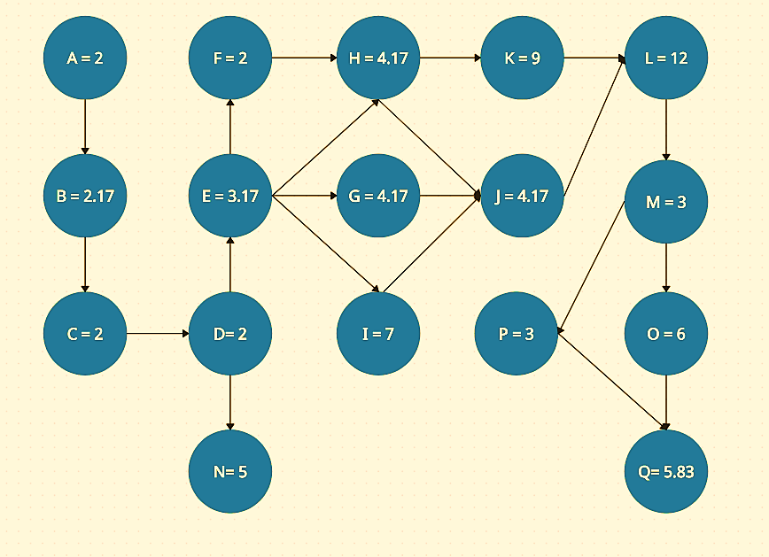

* The critical activity = A + B + C + D + E + F + H + K + L + M + O + Q

= 2 + 2.17 + 2 + 2 + 3.17 + 2 + 4.17 + 9 + 12 + 3 + 6 + 5.83 = 53.34 weeks

## Calculator early start and early finish and late start and late finish and free float and total float.

|  |  |  |  |  |  |  |  |  |
| --- | --- | --- | --- | --- | --- | --- | --- | --- |
| Task | Duration | ES | EF | LS | LF | Free float | Total float | Critical  path |
| A | 2 | 0 | 2 | 0 | 2 | 0 | 0 | ☑ |
| B | 2.17 | 2 | 4.17 | 2 | 4.17 | 0 | 0 | ☑ |
| C | 2 | 4.17 | 6.17 | 4.17 | 6.17 | 0 | 0 | ☑ |
| D | 2 | 6.17 | 8.17 | 6.17 | 8.17 | 0 | 0 | ☑ |
| E | 3.17 | 8.17 | 11.34 | 8.17 | 11.34 | 0 | 0 | ☑ |
| F | 2 | 11.34 | 13.34 | 11.34 | 13.34 | 0 | 0 | ☑ |
| G | 4.17 | 11.34 | 15.51 | 18.17 | 22.34 | 6.83 | 6.83 | ⮽ |
| H | 4.17 | 13.34 | 17.51 | 13.34 | 17.51 | 0 | 0 | ☑ |
| I | 7 | 11.34 | 18.34 | 15.34 | 22.34 | 4 | 4 | ⮽ |
| J | 4.17 | 17.51 | 21.68 | 22.34 | 26.51 | 3.38 | 4.38 | ⮽ |
| K | 9 | 17.51 | 26.51 | 17.51 | 26.51 | 0 | 0 | ☑ |
| L | 12 | 26.51 | 38.51 | 26.51 | 38.51 | 0 | 0 | ☑ |
| M | 3 | 38.51 | 41.51 | 38.51 | 41.51 | 0 | 0 | ☑ |
| N | 5 | 8.17 | 13.17 | 1.17 | 6.17 | 0 | 0 | ☑ |
| O | 6 | 41.51 | 47.51 | 41.51 | 47.51 | 0 | 0 | ☑ |
| P | 3 | 41.51 | 44.51 | 44.51 | 47.51 | 3 | 3 | ⮽ |
| Q | 5.83 | 47.51 | 53.34 | 47.51 | 53.34 | 0 | 0 | ☑ |

## Gantt chart

|  |  |  |  |  |
| --- | --- | --- | --- | --- |
| Task | task | Duration | Start data | End data |
| Requirement Gathering | A | 2 | 1/6/2024 | 15/6/2024 |
| Concept Design | B | 2.17 | 15/6/2024 | 30/6/2024 |
| Prototype Development | C | 2 | 30/6/2024 | 14/7/2024 |
| User Feedback | D | 2 | 14/7/2024 | 28/7/2024 |
| Final Design | E | 3.17 | 28/7/2024 | 19/8/2024 |
| Database Design | F | 2 | 19/8/2024 | 2/9/2024 |
| Frontend Development | G | 4.17 | 19/8/2024 | 17/9/2024 |
| Backend Development | H | 4.17 | 2/9/2024 | 1/10/2024 |
| Content Creation | I | 7 | 19/8/2024 | 7/10/2024 |
| Integration Testing | J | 4.17 | 7/10/2024 | 5/11/2024 |
| Security Implementation | K | 9 | 1/10/2024 | 3/12/2024 |
| Performance Testing | L | 12 | 3/12/2024 | 25/2/2025 |
| Beta Release | M | 3 | 25/2/2025 | 18/3/2025 |
| Marketing Plan Development | N | 5 | 14/7/2024 | 18/8/2024 |
| Bug Fixing | O | 6 | 18/3/2025 | 29/4/2025 |
| User Training and Documentation | P | 3 | 18/3/2025 | 8/4/2025 |
| Final Release | Q | 5.83 | 29/4/2025 | 9/6/2025 |

# Economic Feasibility Study

Purpose for assessing economic feasibility is to identify the financial benefits and costs associated with the development project.

Economic feasibility is often referred to as cost benefit analysis.

**Financial benefits:**

In our management system we are assuming that monetary benefits of our management system at (100,000LE) per year.

And the one-time costs of (50,000LE) and the recurring costs of (40,000LE) a discount rate of 12 percent we are going to calculate the financial benefits over 5 years.

* **The net present value of these cost and benefits of an information system?**
* **The overall return on investment of the project?**
* **Benefits per year 100,000 LE**
* **Recurring cost per year = 40,000 LE**
* **One time cost 50,000 LE**
* **Discount rate = 12%**

$${PV}_{n}=Y* \frac{1}{{(i+1)}^{n}}$$

**Overall NPV = NPV of all benefits – NPV of all costs**

**Overall, ROL = Overall NPV / NPV of all costs**

|  |  |  |  |  |  |  |  |
| --- | --- | --- | --- | --- | --- | --- | --- |
|  | Year of project | | | | | | |
| **Year0** | **Year1** | **Year2** | **Year3** | **Year4** | **Year5** | **Total** |
| Net benefits | 0 | 100,000 | 100,000 | 100,000 | 100,000 | 100,000 | ____ |
| Discount rate | 1 | 0.8928 | 0.7972 | 0.7118 | 0.6355 | 0.5674 | ____ |
| PV benefits | 0 | 89,285.71 | 79,719.38 | 71,178.02 | 63,551.80 | 56,742.68 | ____ |
| NPV of all benefits | 0 | 89,285.71 | 169,005.09 | 240,183.11 | 303,734.91 | 360,477.59 | 360,477.59 |
| One time cost | 50,000 | ____ | _____ | _____ | _____ | _____ | ____ |
| Net economic cost | 0 | 40,000 | 40,000 | 40,000 | 40,000 | 40,000 | ____ |
| Discount rate | 1 | 0.8928 | 0.7972 | 0.7118 | 0.6355 | 0.5674 | ____ |
| PV of costs | 0 | 35,714.2 | 31,887.7 | 28,471.2 | 25,420.7 | 22,697.1 | ____ |
| NPV of all costs | 50,000 | 85,714.2 | 117,602 | 146,073.2 | 171,494 | 194,191 | 194,191 |
| Overall NPV | ____ | ____ | ____ | ____ | ____ | ____ | 166,286.59 |
| Overall ROI | ____ | ____ | ____ | ____ | ____ | ____ | 0.85 |

* **Present a break-even analysis of, at what point does break-even analysis occur?**

**Yearly PV cash flow= Yearly PV (benefit) – Yearly PV (cost)**

**Yearly overall NPV cash flow = Yearly NPV (benefit) – Yearly NPV (cost)**

|  |  |  |  |  |  |  |
| --- | --- | --- | --- | --- | --- | --- |
| Year | Year 0 | Year 1 | Year 2 | Year 3 | Year 4 | Year5 |
| Yearly PV cash flow | 50,000 | 53,571.51 | 47,831.68 | 42,706.82 | 38,131.10 | 34,045.58 |
| Yearly overall NPV cash flow | 50,000 | 3,571.51 | 51,403.09 | 94,109.91 | 132,240.91 | 166,286.59 |

$$Break point= \frac{(yearly PV cash flow –yearly overall NPV cash flow) }{yearly PV cash flow}$$

$$Break point= \frac{53,571.51-3 , 571.51}{53,571.51}=0.93$$

Break point occurs at 1.39.

# Data flow diagram

## A diagram of a child's application process Description automatically generatedContext diagram (Level 0)

## data flow diagram (Level 1)

1. Administrator

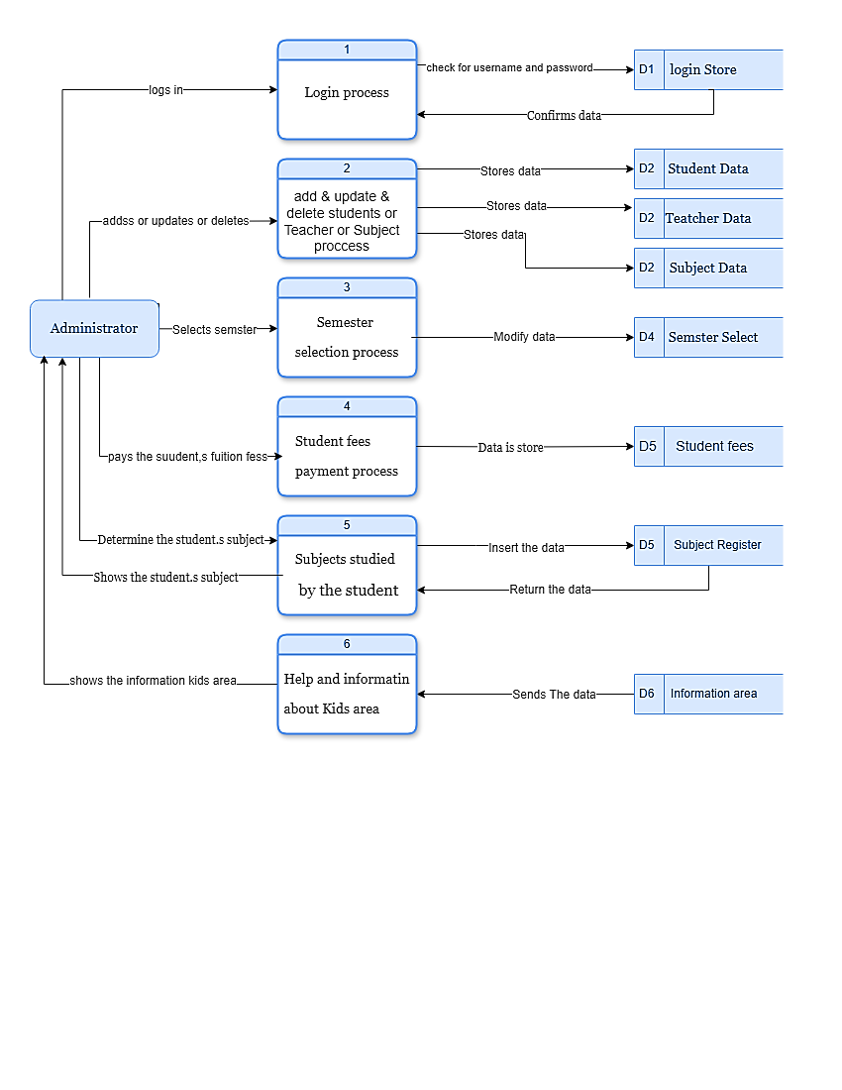

1. 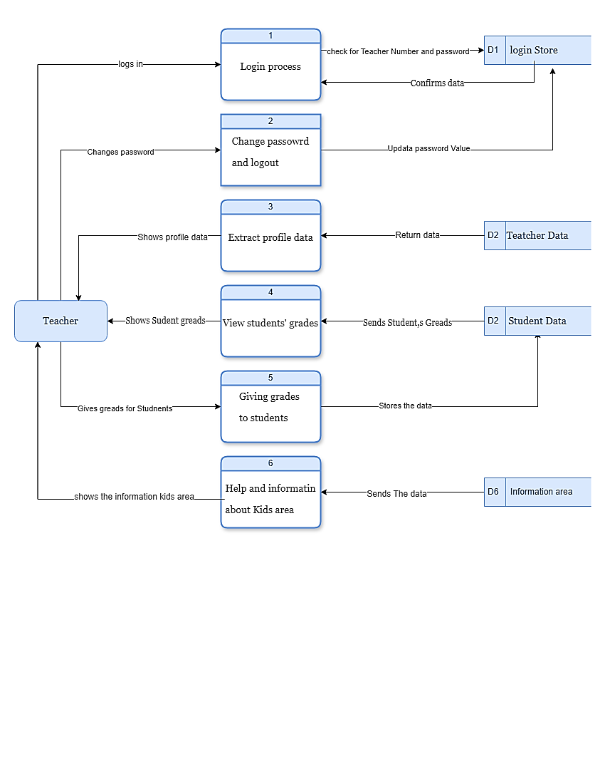Teacher
2. 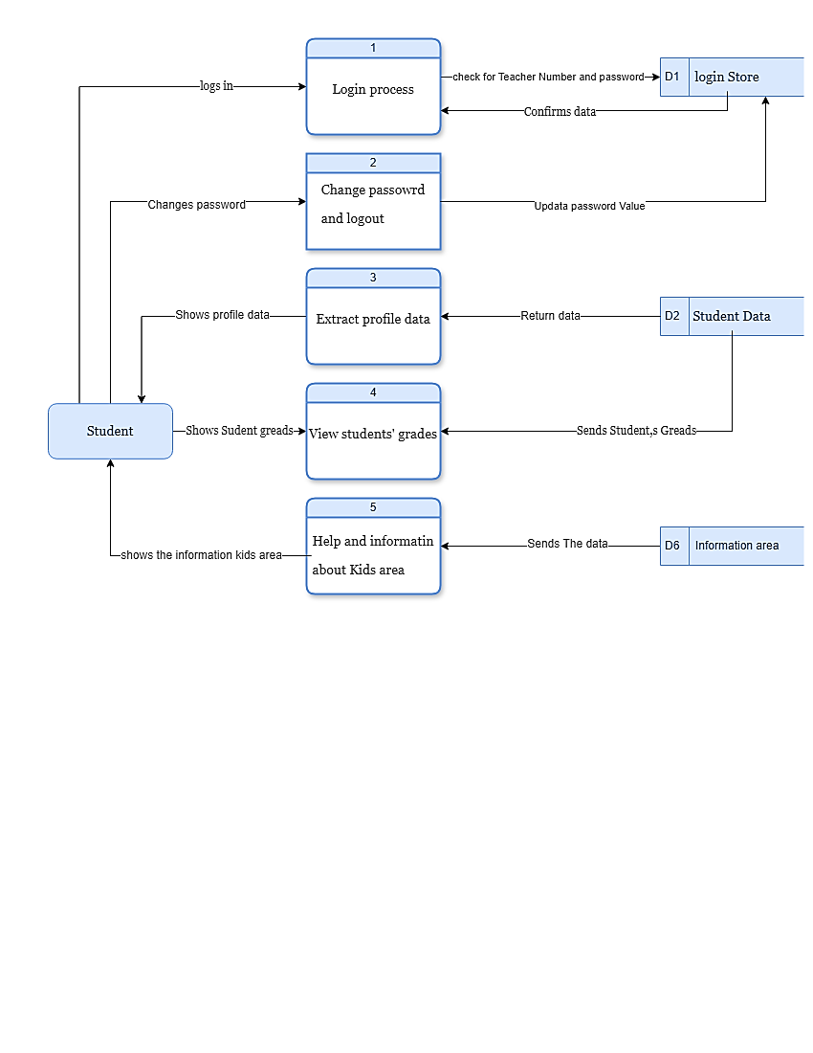Student

# Use Case

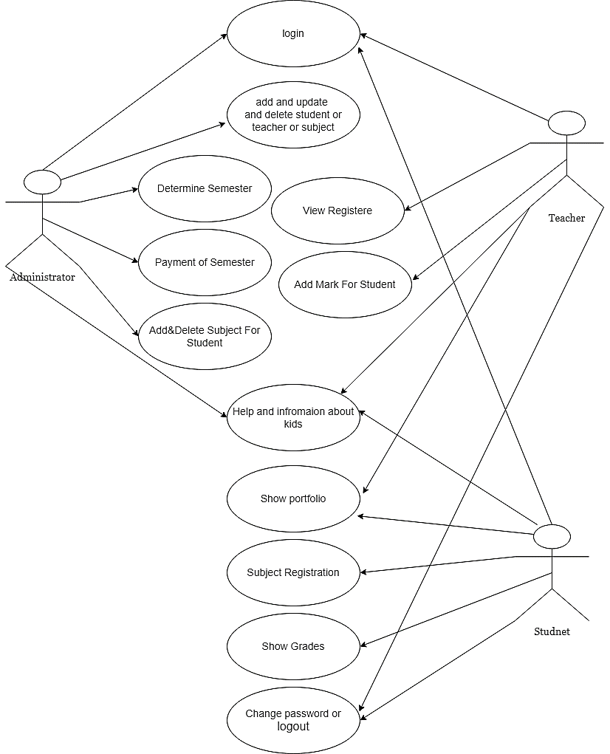

# Activity diagram

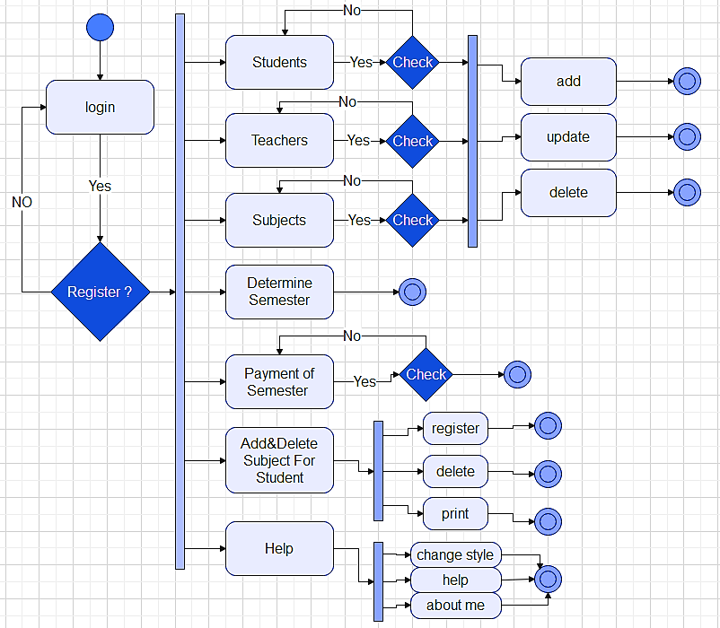administrator

# Design and implementation.

Admonitor

The Admonitor logs in through this screen.

If the Username and password are correct, you can log in.

If it is wrong, he cannot enter.

**Username: agami**

**password: 123456**

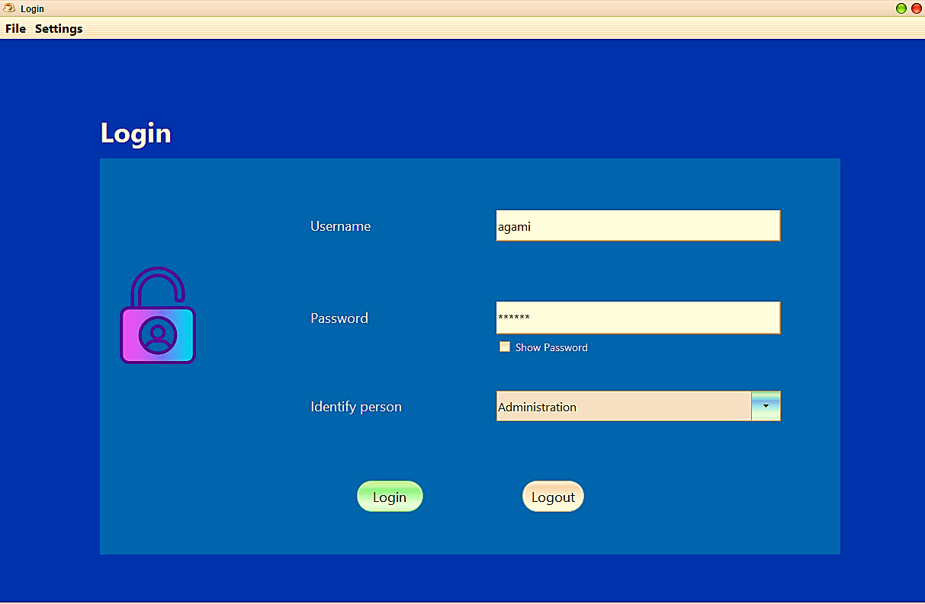

The Administrator's home page will be available to him:

* Add or update or delete Students.
* Add or update or delete Teacher.
* Add or update or delete Subject.
* Determine Semester
* Payment of Semester
* Add or Delete subject for Student.

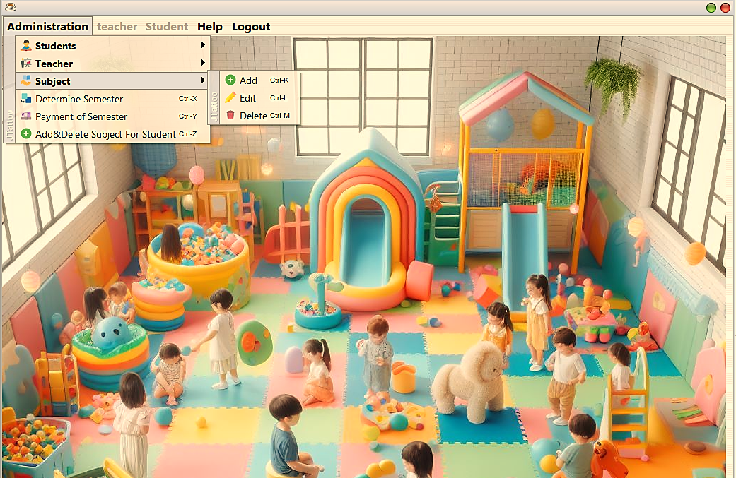

The administrator adds, updates, or deletes the data of a Students, Teachers, or Subject.

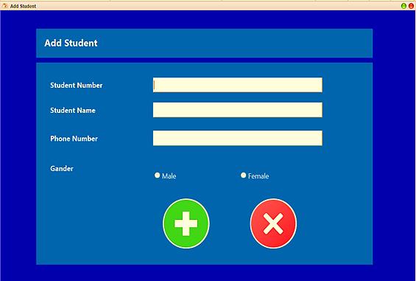



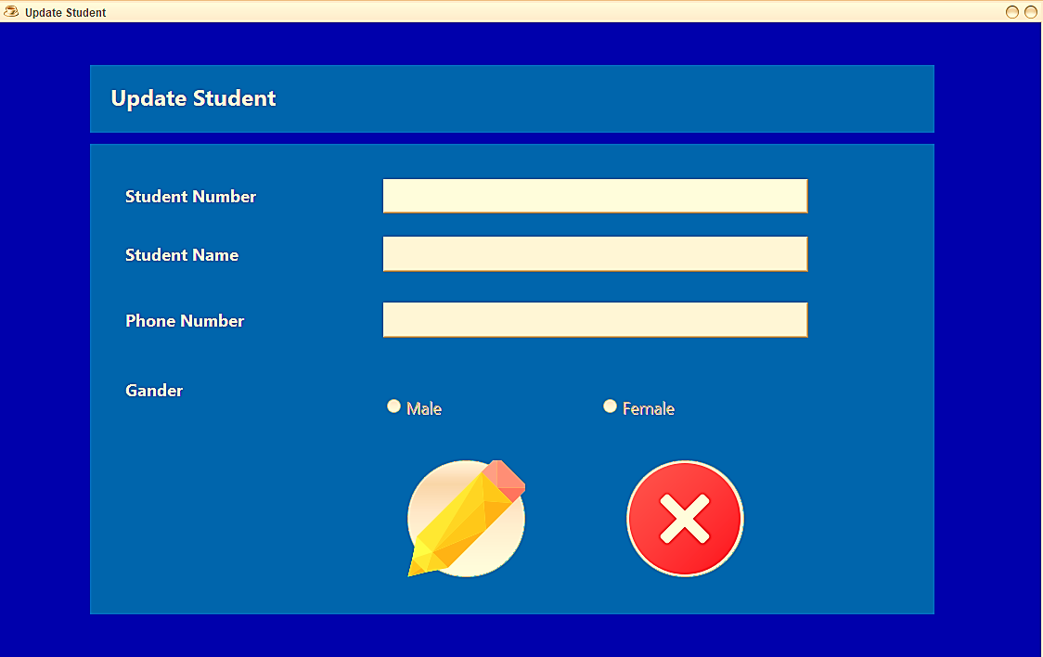



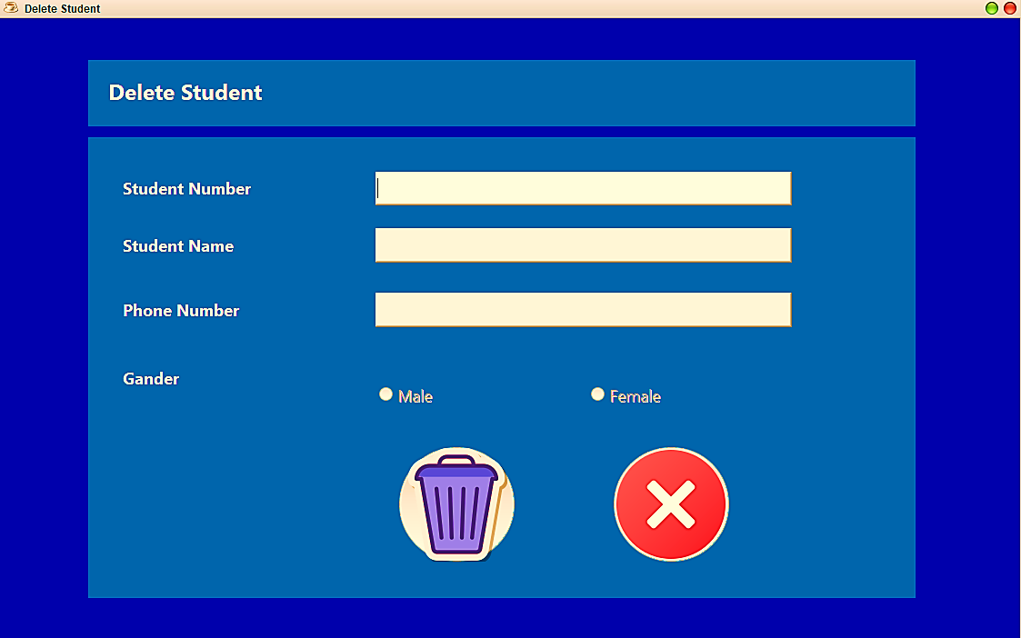

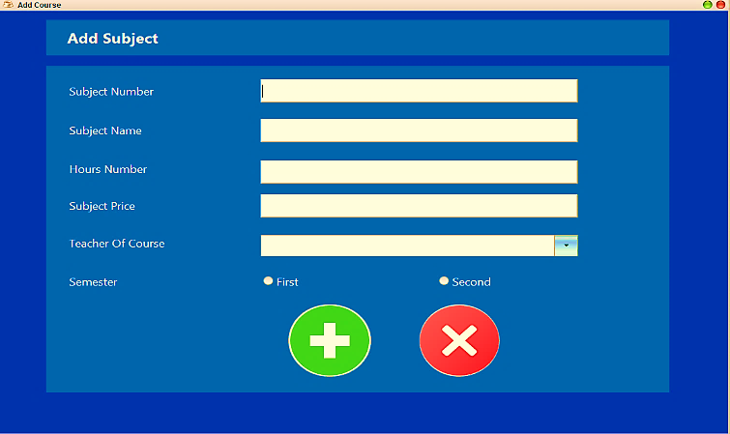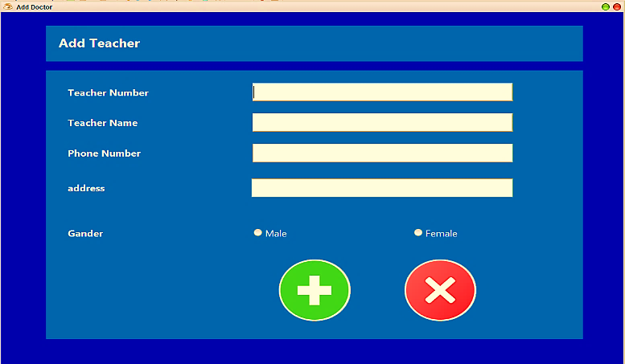****

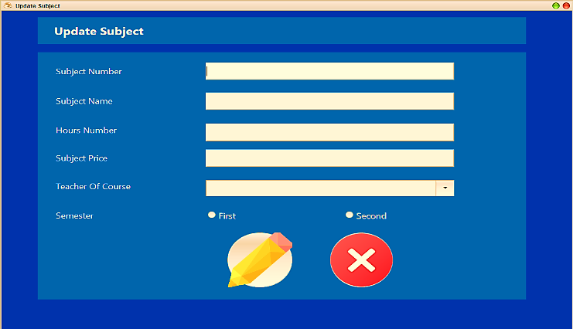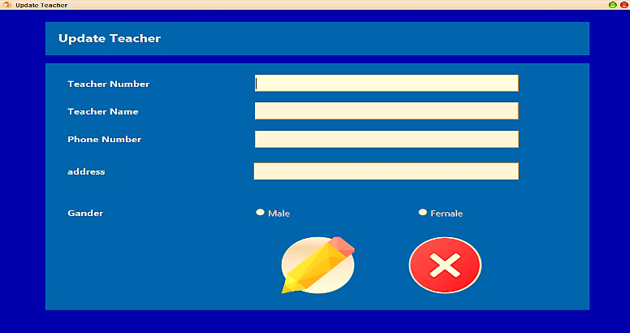****

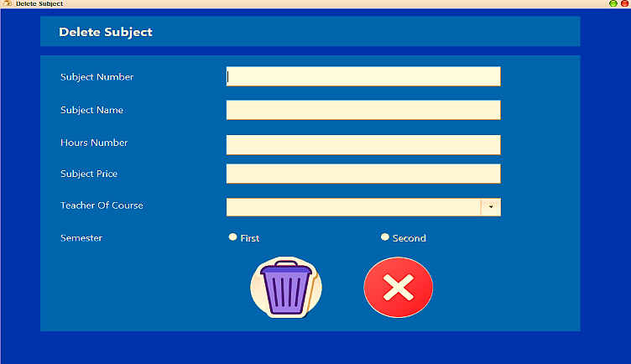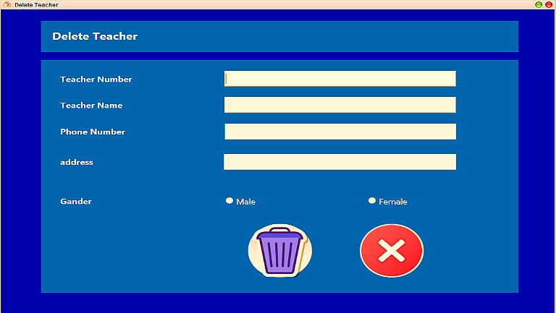****

The administrator sets the semester and pays the students' tuition fees.

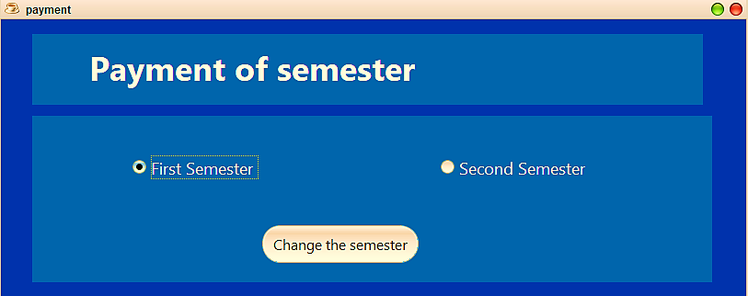



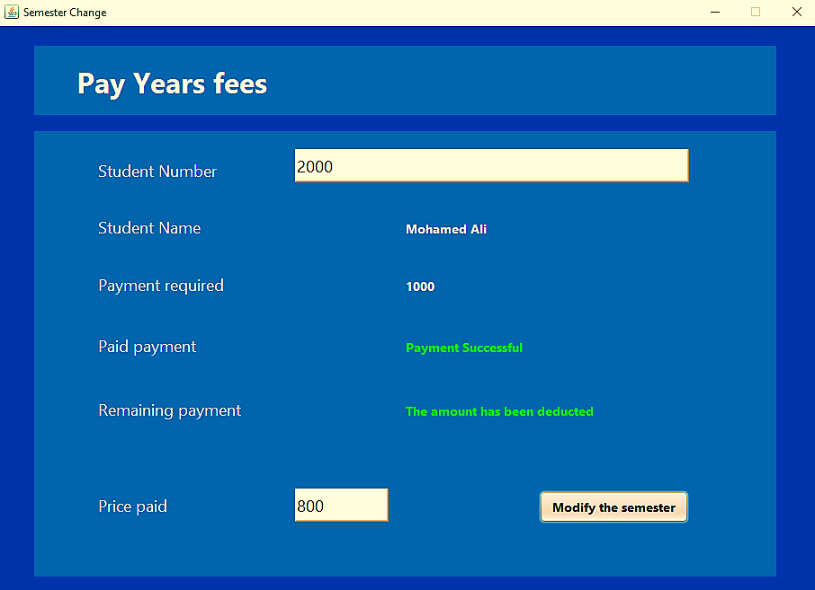

The director presents the subjects the student is required to study.

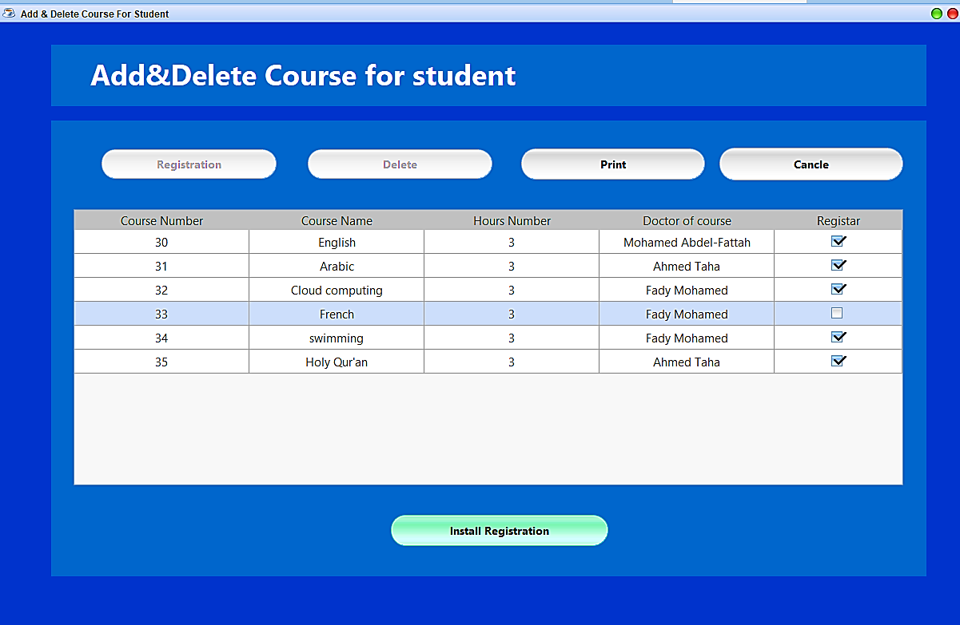****

Teachers

The Teacher logs in through this screen.

If the Teacher Number and password are correct, you can log in.

If it is wrong, he cannot enter.

**Teacher Number: 111**

**password: 000**

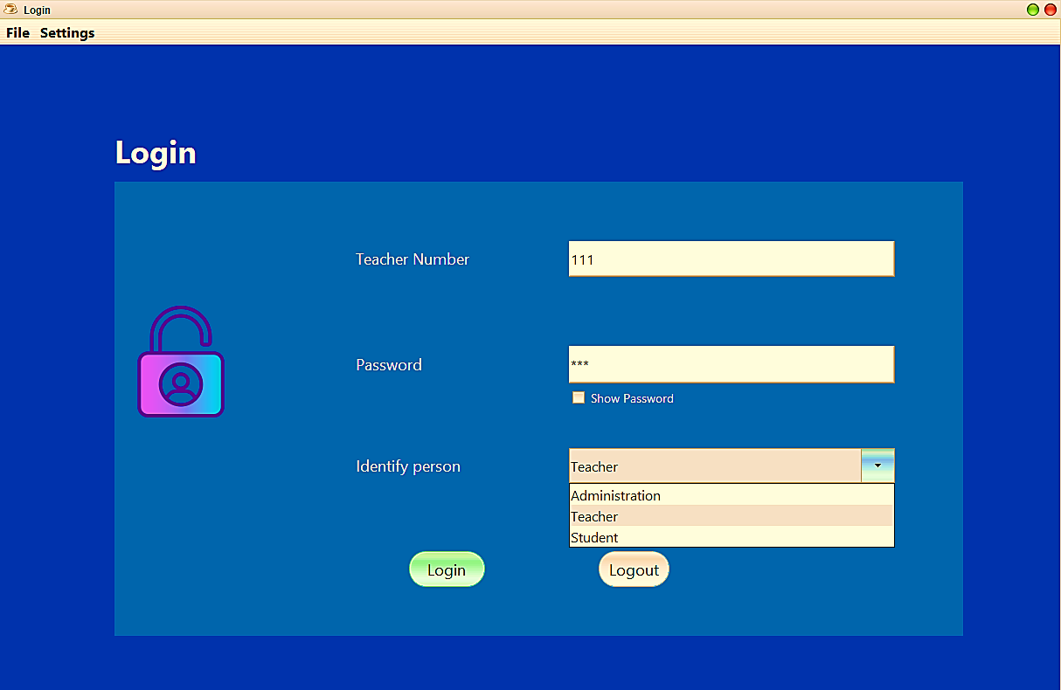

The Teacher’s home page will be available to him:

* Show your portfolio.
* View registered students for the Subjects.
* Adds Student Greats for Students
* Change Password
* Help and logout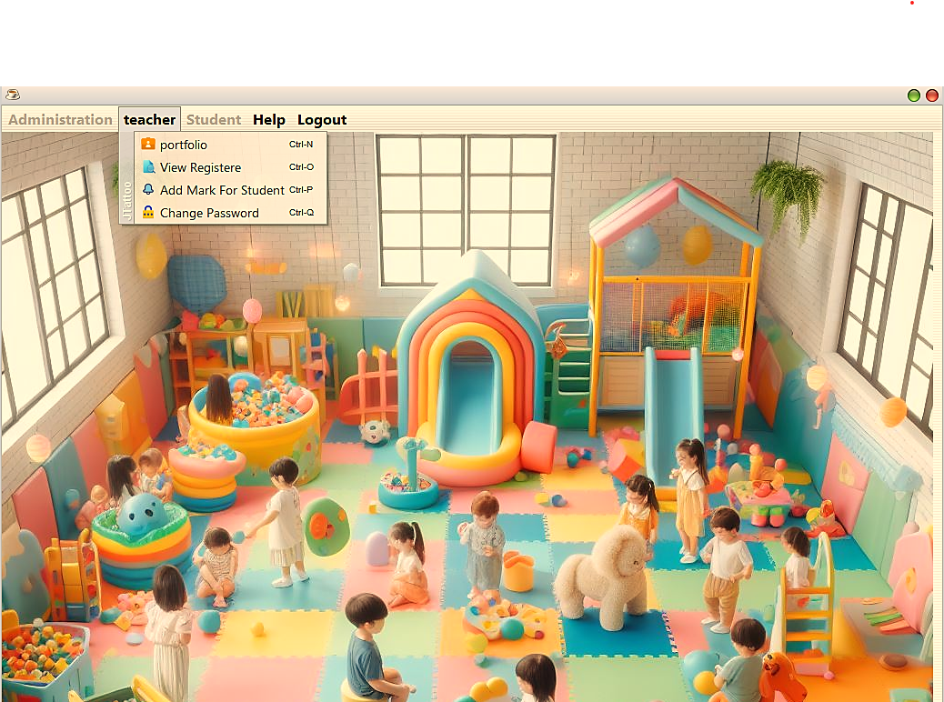



Through this page, the teacher can view his own page and the data it contains.

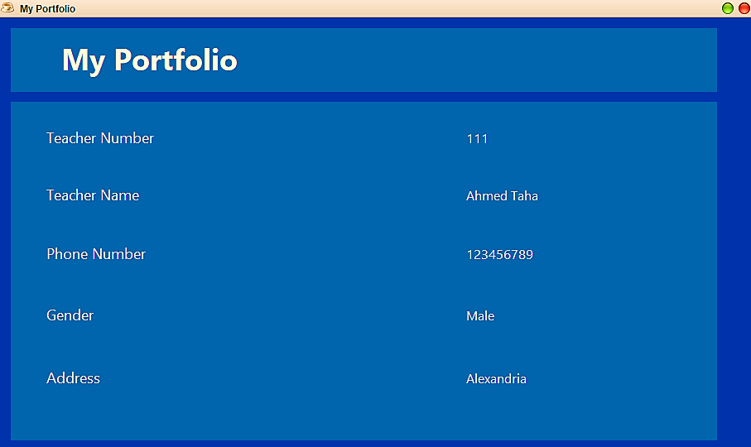

Through this screen, the teacher tallies the grades of all students in all subjects taught by this teacher.

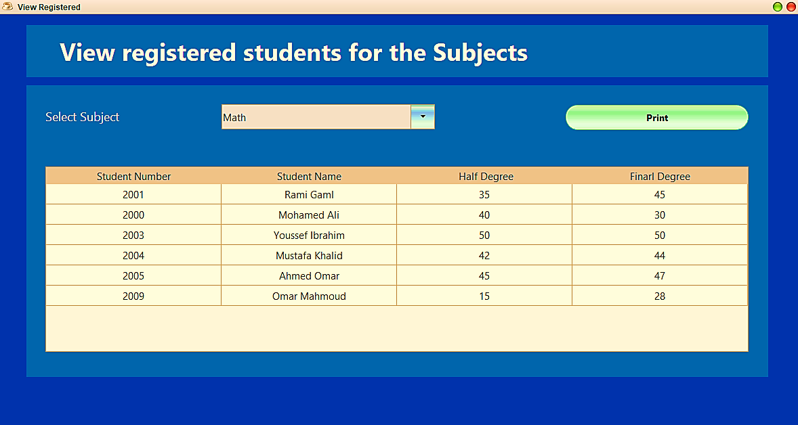

Through this page, the teacher can add student grades and change the password.



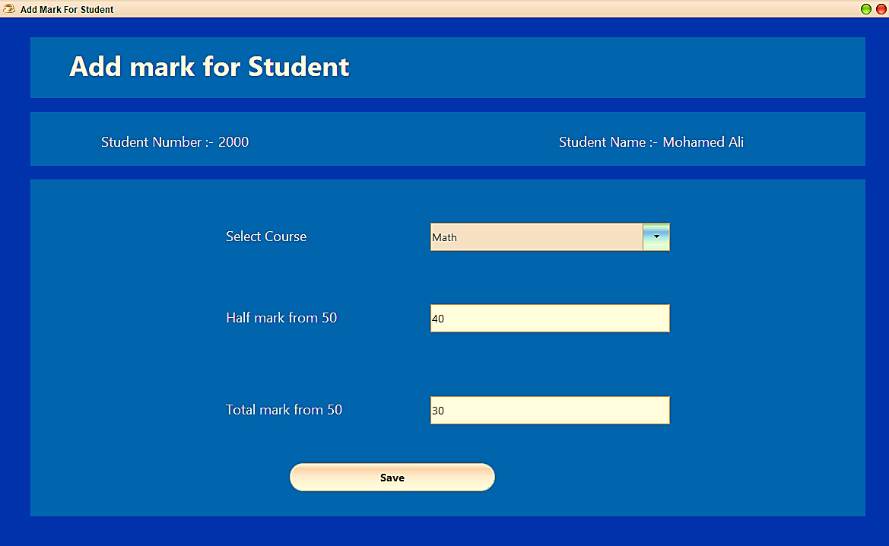



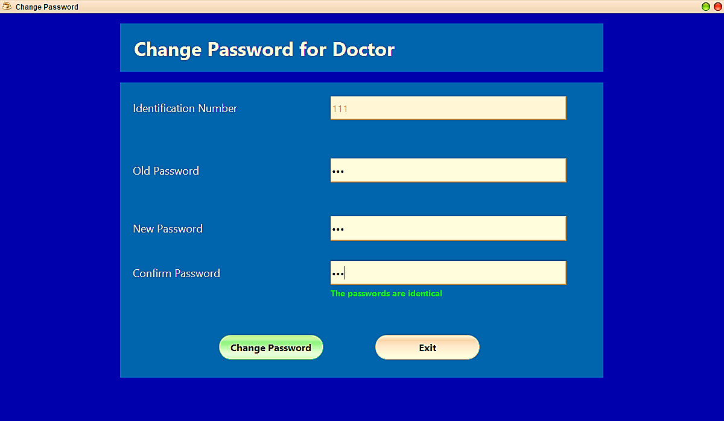

Student

The Teacher logs in through this screen.

If the Student Number and password are correct, you can log in.

If it is wrong, he cannot enter.

**Teacher Number: 200**

**password: 123**

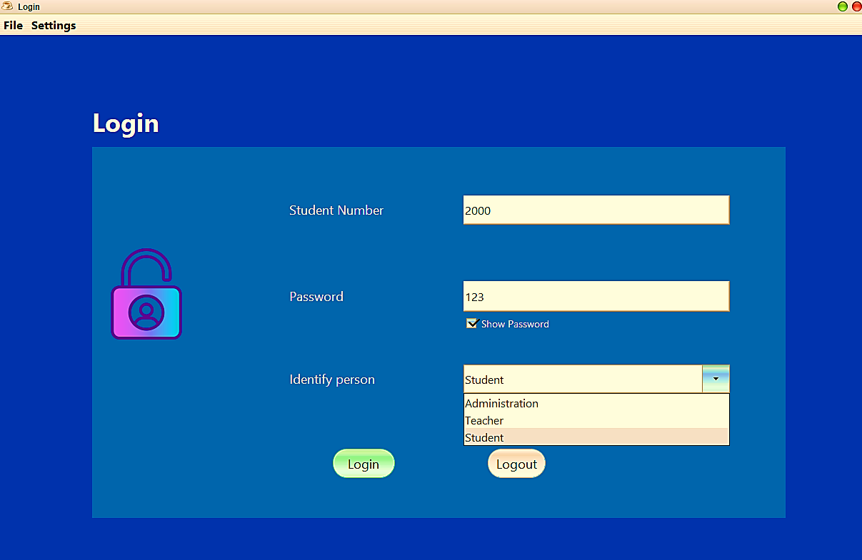

The student’s home page will be available to him:

* Show your portfolio.
* View subject Registration.
* View his grades.
* Change Password
* Help and logout.

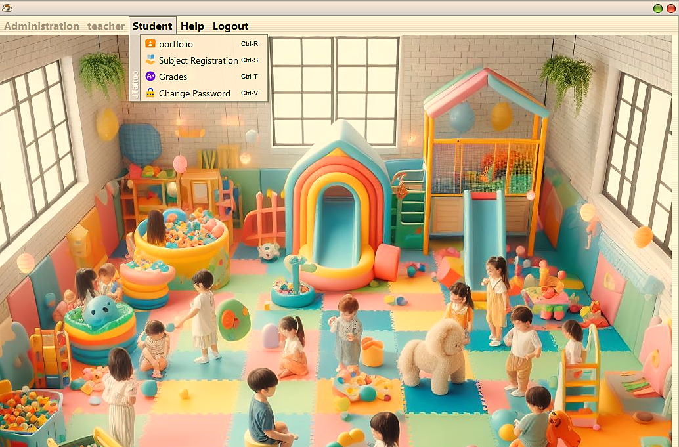

# Testing

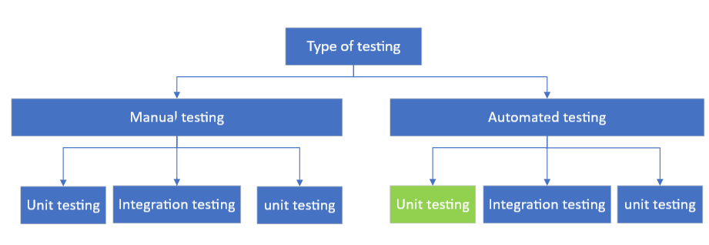***White box testing***

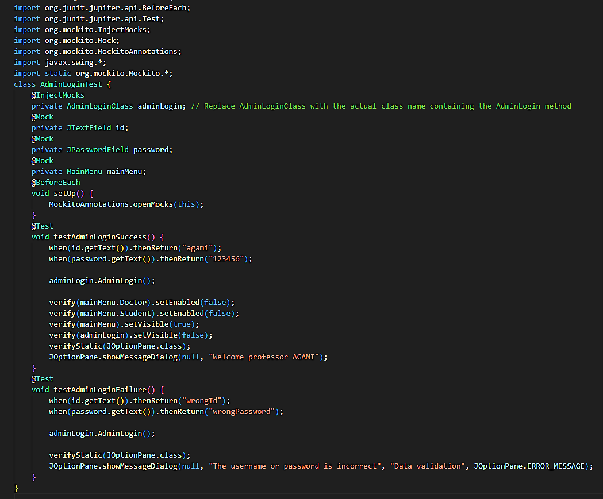***function administration login***

***Project files***



